Name: Smruti Padhi

Roll No.: 21251

Sec: CSE C

1) Locating the Main_Directory

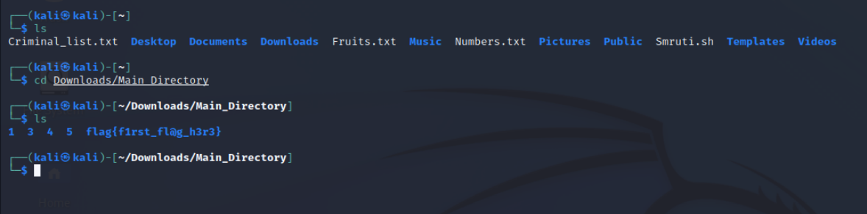

2) First flag: flag{f1rst_fl@g_h3r3}

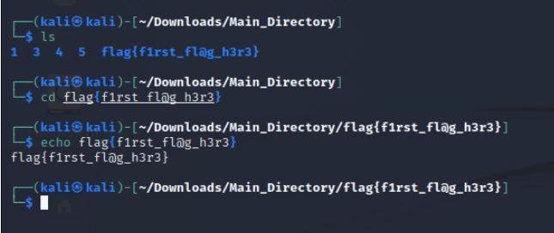

3) Second flag: flag{t@c_15_fun!}

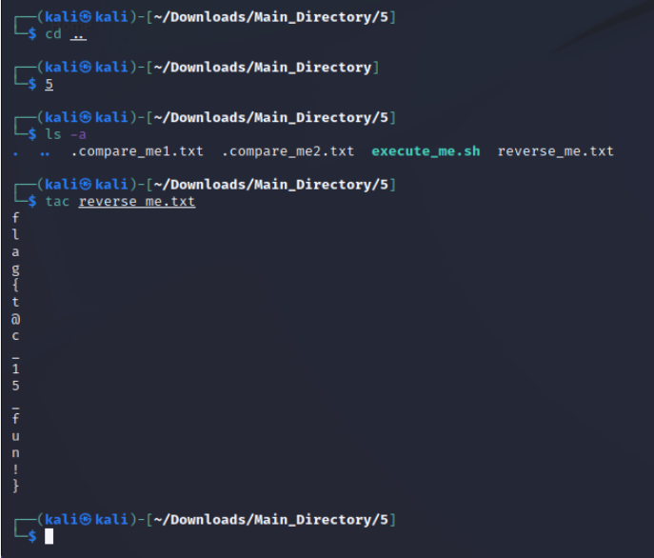

4) Third flag: flag{3x3cut10n_d0n3!}

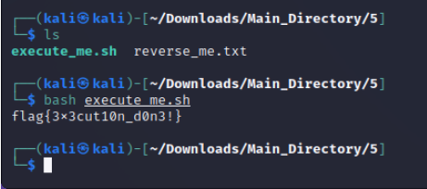

5) Fourth flag: flag{d1ff_c0mm@nd15_u53ful!}

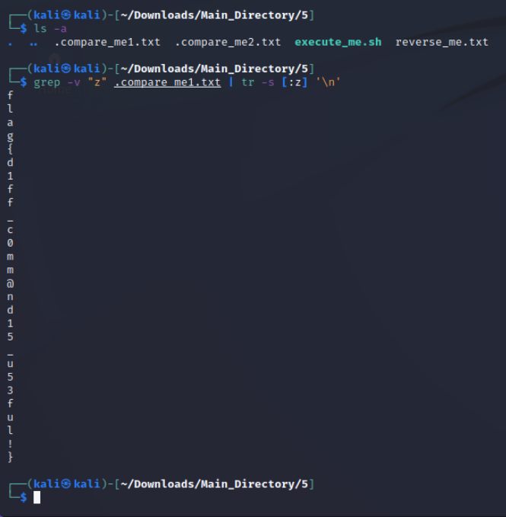

6) Fifth flag: flag{t3xt_15_n0t_h1dd3n!}

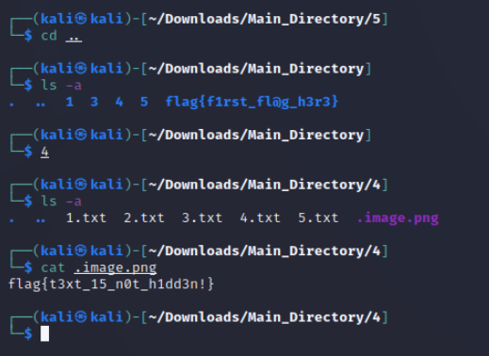

7) Sixth flag: flag{m3ow_m3ow_cat!}

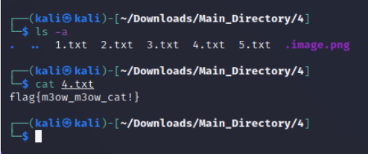

8) Seventh flag: flag{h1dden_fil3!}

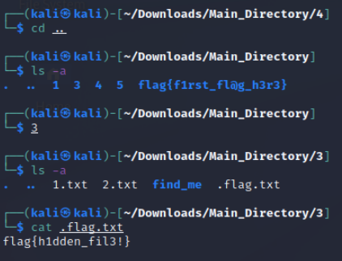

9) Eight flag: flag{gr3p_f1nds_fl@gs!}

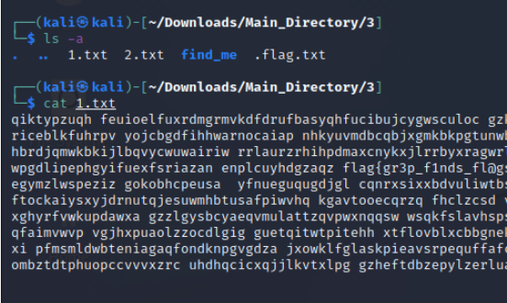

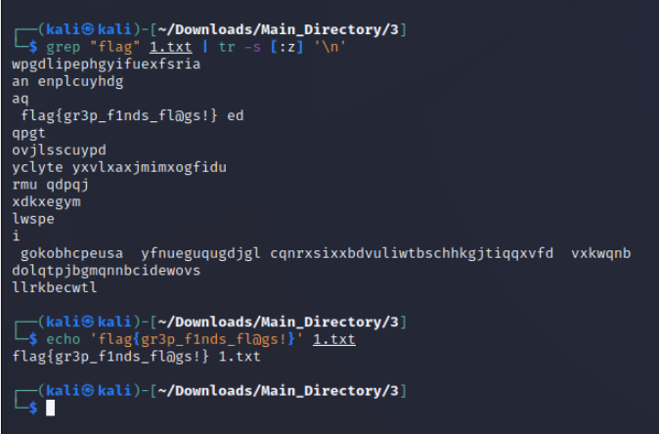

10) Ninth flag: flag{Y0u_f0und_m3!}

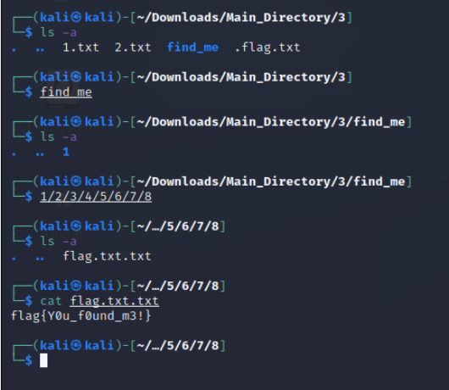

11) Tenth flag: flag{Y0u_f0und_th3_hidd3n_dir!}

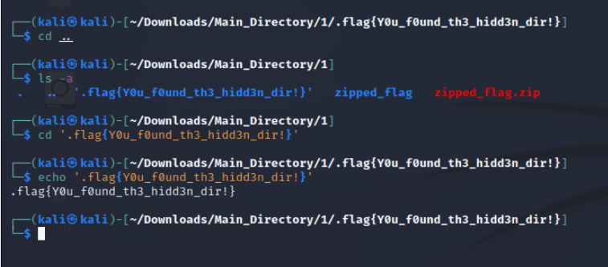

12) Eleventh flag: flag{e@5y_p@ssw0rd!}

